TASK-4: Order Management using Joins
AIM: Build an Order Management system to manage customers, products, and orders, and display insights like highest order and most active customer using SQL joins and subqueries.

Algorithm:
- Create database and tables (customers, products, orders)
- Insert sample data into tables
- Use JOIN query to fetch customer order history
- Use subquery to find highest value order
- Use subquery to find most active customer
- Build backend APIs using Node.js
- Fetch data using JavaScript (fetch API)
- Display results in HTML table
Code:
Index.html
<!DOCTYPE html>
<html>
<head>
<title>Order Management</title>
<link rel="stylesheet" href="style.css">
</head>
<body>
<h1>Order History</h1>
<button onclick="loadOrders()">Load Orders</button>
<table id="ordersTable"></table>
<h2>Insights</h2>
<button onclick="highestOrder()">Highest Order</button>
<p id="highest"></p>

<button onclick="activeCustomer()">Most Active Customer</button>
<p id="active"></p>
<script src="script.js"></script>
</body>
</html>
Style.css
body {
font-family: Arial;
text-align: center;
}
table {
margin: auto;
border-collapse: collapse;
}
td, th {
border: 1px solid black;
padding: 10px;
}
button {
margin: 10px;
padding: 10px;
}
Script.js
function loadOrders() {
fetch("http://localhost:3000/orders")
.then(res => res.json())
.then(data => {
let table = "<tr><th>Name</th><th>Product</th><th>Qty</th><th>Total</th></tr>";
data.forEach(o => {
table += `<tr>
<td>${o.name}</td>
<td>${o.product}</td>
<td>${o.quantity}</td>
<td>${o.total}</td>
</tr>`;
});
document.getElementById("ordersTable").innerHTML = table;
});
}
function highestOrder() {
fetch("http://localhost:3000/highest")
.then(res => res.json())
.then(data => {
document.getElementById("highest").innerText =
"Highest Order: ₹" + data[0].total;
});
}

OUTPUT1: Highest value order
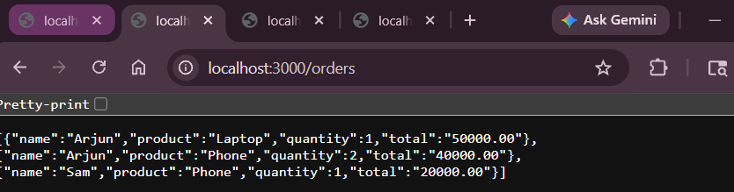
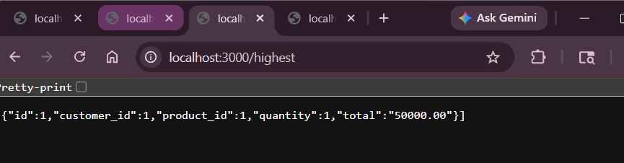

OUTPUT2: Most active customer
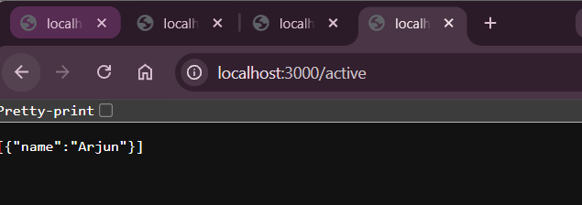

Result: System displays order details using JOIN queries.
It also shows highest order and most active customer using subqueries.

